ECOTOURISM-BASED SETTLEMENT PLANNING
in karangdalem i settlement, bongkasa pertiwi -bali

A.A. Gede Raka Gunawarman¹, Ni Luh Anik Puspa Ningsih², Made Suryanatha Prabawa³,
¹Architectural Department, Universitas Warmadewa, Jalan Terompong No.24, Denpasar, Indonesia
²Economy Department, Universitas Warmadewa, Jalan Terompong No.24, Denpasar, Indonesia
³Architectural Department, Universitas Warmadewa, Jalan Terompong No.24, Denpasar, Indonesia
dapurpoleng@gmail.com ¹

ABSTRACT
The group of Silver Craftsman Cipta Karya Pertiwi Br. Karang Dalem I of the Bongkasa Pertiwi Village, Abiansemal-Badung has the potential to be developed as a tourist destination. This potential is still not able to be processed properly considering the declining silver crafters that do exist in Br. Karang Dalem I. A fundamental problem that needs special attention is that the traditional silver crafters will not become extinct because they are defeated by silver artisans with machines in other areas. The residential environment owned by Br. Karang Dalem I has also become an asset that has a high sale value with a unique atmosphere of a traditional Balinese residential environment. It just needs a little touch so that the face of this region is increasingly supportive as a tourist destination with productive economic products. Lack of understanding and awareness of partner groups about products, management, and the environment are fundamental issues raised in this PKM. The solutions offered are divided into 3 parts: solutions for products, management and environmental management. The output of the solution in the aspect of product production is a change in the mechanism of the production process without reducing production details and traditions. The output of management solutions is improving business performance and community welfare. The output of settlement settlement structuring solutions is the changing face of a stronger environment into a tourism-worthy environment with architectural and landscape elements.
Keywords: Silversmiths; Settlements; Tourism

INTRODUCTION
Bongkasa Pertiwi village was a villa located in Abiansemal, Badung Regency. It is located in high ground with approximately altitude: 312 m above sea level, with tropical climate and average temperature around 30°C. Bongkasa Pertiwi Village consist of 3 Banjar (Hamlets): Banajar Karangdalem I; Karangdalem II, and Banjar Tegal Kuning. On the east side oh this village lies Ayung River which also exist as boundary between Bongkasa Pertiwi Village and Gianyar Regency.
According to site survey activities, silversmith was once a popular profession that many of the villager do to earn money for living. But, as time flows silversmiths profession became more and more unpopular anymore between villagers. On the first time long ago there were 79 (seventy nine) silversmiths in Bongkasa Village, in 2005 only 15 remains, and what is the worst thing is in 2018 only 8 silversmiths left in bongkasa village until now (2019). Silversmiths in Bongkasa Village use traditional methods in creating some jewelry using silver as it’s main material, and the way still preserve by the remaining silversmiths until now. Villagers who do silversmiths is formed in an association named “Kelompok Perajin Perak Cipta Karya Pertiwi”.
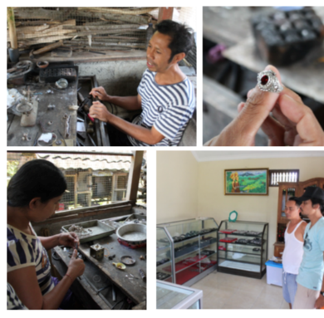
Gambar 1. 1 Activities of Silversmiths Group in Banjar Karangdalem I
Source: Suryanatha’s Documentation, September 2019
Badung Regent’s Rules No. 47 year 2010 about Tourism Village Region Establishment, determine 11 villages as tourism villages. Those tourism villages consist of (1) Pangsan Village; (2) Carangsari Village; (3) Bongkasa Pertiwi Village; (4) Sangeh Village; (5) Mengwi Village; (6) Belok Village; (7) Petang Village; (8) Pelaga Village; (9) Munggu Village; (10) Baha Village; and (11) Kapal Village. For Bongkasa Pertiwi Village the rules especially mentioned Banjar Karangdalem I as focus area of tourism regarding tourism village establishment. Because of its special condition, Banjar Karang Daem I with its silversmiths, can be mentioned as main tourism attraction potency in Bongkasa Pertiwi as Tourism Village.
Not Just silversmiths that got attention in Banjar Karangdalem I, but also Villager’s Compound of Houses with their regular activities also get some attention. Houses of silversmiths that located in Banjar Karangdalem I preserved Bali’s traditional spatial arrangement system. Not just the Spatial Arrangement, but also its space/room, form, style, and its building materials were all well preserved as it first built. In the area of Public street, the linearly alignment of silversmiths house compunds also still preserved a traditional bali ambience through its Kori (entrance into house) arrangement of each houses and front garde known as “Telajakan” with its traditional balines vegetation such as Jepun, Plawa, etc.
With such many attaction potencies from villagers uniques profession, activities, houses, public spaces, Banjar Karangdalem I can be made as Tourism Destination. Attraction that can be given for tourists as an experience where not all village in Bali has, such as experiencing traditional housing landscapes; spatial arrangement, silver workshop, value and meaning regarding villager way of life, and so on. Those can be served as attraction because it still preserving traditional value, basically tourist will be much interested in knowing something behind unique phenomenon, and thats what Banjar Karangdalem I settlement and it’s silversmiths has.

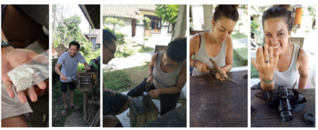
Gambar 1. 2 Silversmiths Workshop Class attende by Tourist in Wayan Pastika’s (Silversmith) House
Source : Pastika Documentation, 2018
Tourism Village was a village area that offers authenticities wether from social-cultural, customs, daily life, traditional architecture, village spatial arrangement that serve as a form of integration between tourism components such as attractin, accommodation, and supporting facilities (Darsono in Zakaria, 2014). According to pharagraph before, Karangdalem I Settlement is perfectly fitted for title “Tourism Village” in the future.

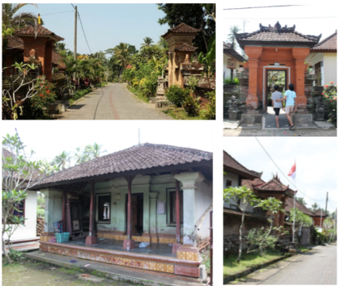

Figure 1. 3 Silversmiths Settlement Ambience, Kori (Entrance) into House, and Balinese Traditional House in Banjar Karangdalem I.
Sumber : Dokumentasi Suryanatha, 2018

Silversmiths in Banjar Karangdalem I has some weaknesses if they would like to served as Tourism Village main attraction. Weakness such as : Management system in production and marketing so that they can produce something attractive. The amount of silversmiths remaining is also going down each year and silversmiths in Banjar Karangdalem I serves as second parties in silver jewelry trade, or in other words buyer do not buy silver jewelry directly through silversmiths. Many of silver buyer prefer to buy from Celuk Village so Celuk Village buy some products from Karangdalem I Silversmiths. Human ressources has a role to face competition, human ressources quality, competency, and product innovation (Setyanto, 2015). Seeing human ressources and environmental potencies of Banjar Karangdalem I settlement that also need optimization, make a reason why silversmiths involved in PKM activities in 2019.

METHODOLOGY
Silversmiths Group of Banjar Karangdalem I, Bongkasa Pertiwi Village, Badung has 3 major problems, 3 major problems consist of : Production, management, and settlement planning. Those 3 problems will become priority to find it’s solutions. For production problem, systematically solution that can be offered is planning and management production, starts from creating product standard from quality and quantity aspects, making a cooperation between silversmiths through applying subcontracted methods whan there is high-demand of silver product; improvement in competitiveness on handmade products that generated through design, model, and product improvement; doing management in chain of demand to maintain main materials supply in production process, maintain workers, determining product price competitively also design attractive jewelry production process flow (experience based) as tourism attraction of Banjar Karang Dalem I, Desa Bongkasa Pertiwi.

Meanwhile for the business management, silversmiths will be thought from money management, marketing, and human ressources. Financial business aspect about managing fund also alternative sources of fundings which always be a problems for micro and middle class business, also doing funding management and strategy to determine competitive product price. Marketing aspects applied marketing strategy via offline and online. Starts from the nearest which is developing cooperation in Banjar or Village (desa), some community groups or marketing group in villages. Providing showroom in Banjar/Village levels where all silversmiths can show of their products to tourists or consumer. Marketing strategy using technology such as social media and website regarding products, tourism attraction, and tourism accommodation (homestay).
In terms of improving human ressources, silversmiths need to have a place as central production in Banjar/ Village and the goal is as a place for conduct some training or workshop for making products from senior silversmiths to the youngsters (truna-truni) in Banjar or Villages so knowledge transfer can preserve silversmith skill in the future at the hands of the young.
Especially for the spatial planning problems, it is suggested to do revitalization on physical asects of the main road of Banjar Karang Dalem I as an early face of Karang Dalem I settlement, starts from street garden planning with landscapes elements such as vegetation, street furniture, signage, and road lights. Then, continue by doing uniformty of Kori (entrance into house), house yard planning especially for villager work as silversmith that needs design for adding workshop area, showroom, homestay accommodation, and yard. Yard arrangement plan conducted by assessing every building that worth to get a make-over or land that can be develop to meet the needs for tourism.
The outcome of production or product management is production process of mechanism by not decreasing production detail and tradition. Production can be conducted between silversmiths as a form of joint operation. The outcome of management aspect is improvement in business and people welfare. It can be measured by improving seeling quota, asset groeth, and beneficial improvement and also number of tourist visit. The outcome of spatial arrangement solution is making changes in environmental looks that can represent tourism-friendly environment with the combination of architectural and landscape elements.

RESULTS AND DISCUSSION
Settlemet Area as Tourism Attraction

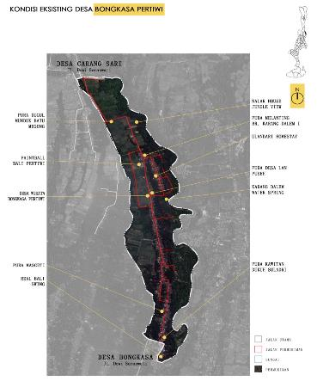
Figure 5. 1 Tourism Attraction Potencies in Bongkasa Pertiwi Villages
Source : Suryanatha, 2019
Based on field survey, today bongkasa village has some potential tourism attractions such as Real Bali Swing, Kawitan Dukuh Suladri Temple, Masceti Temple, Beji Karang Dalem, Paintball, etc. But, between those potencies, there is one which is very famous among tourists, it is Real Bali Swing. Real Bali Swing also mentioned as the main tourism attraction in Bongkasa Pertiwi Village. As a main attraction researcher would like to use the popularity of Real Bali Swing as a beacon to make other tourism attraction potencies exposed to tourists who visit the village.
Silver craftsman settlement in Banjar Karang Dalem I was one of many tourism potencies that Bongkasa Pertiwi village has. Banjar Karang Dalem I was mentioned as tourism destination called “Desa Wisata” in Regent Rules No. 47 year 2010. From that researchers knew that the government also already realise settlements and activities in it can be made as tourism attraction. The settlement consist of houses compounds that most of them still preserve traditional Balinese architectural concept in arrangement of building masses, ornaments, and all spaces still used for traditional activities such as traditional ceremony or daily routines. The public environment of the settlement ( main roads, street garden ) also still preserve balinese traditional village layouts and ambience. The most unique selling point as a tourism destination in the future is Traditionaln Silver Craftsmanship that some of the villager stiil preserve as their way of living and profession. Together, first : Traditional Settlement Environment; Second: Traditional Villager House Compound; Third: villager’s hospitality, and fourth: Traditional Silver Craftsmanship, all four can be realise as a Unique Tourism Destination that can attract many tourists in the future through optimal planning of building and environment. As mentioned in Undang-Undang Republic of Indonesia No. 10 year 2009 about Tourism: Toursim Attractions was a place/thing/etc that has uniqueness, beautifulness, and value/meaning that can be a natural elements, culture, and a thing that man made through unique/traditional ways that can be the target of tourism visits.
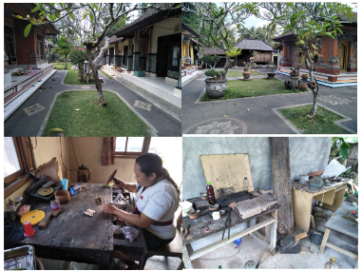

Figure 5. 2Traditional House Compound and Silver Craftsmanship in Banjar Karang Dalem I
Source : Suryanatha, 2019

Designing an Attractive Settlement Facade
The design purpose is making a good first impression of Bannjar Karang Dalem I / Karang Dalem I Settlement, thoruh optimal design on street garden to develop a strong Balinese traditional ambience that as good as Penglipuran Village in Bangli, which is already famous.
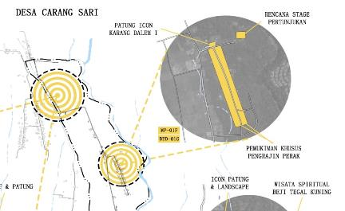

Figure 5. 3 Location of Karang Dalem I Settelement: Silver Craftsman Houses
Source : Suryanatha, 2019

Through drone survey on settlement area researcher could analyses what kind of design can be applied so that it won’t be called as destroying the environment but called a good preservation through efficient planning.
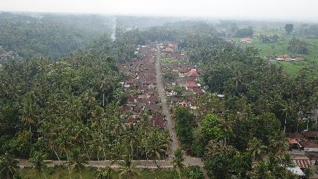

Figure 5. 4 Drone Survey Photo on Settlement Area
Source : Suryanatha, 2019
Angkul-angkul or Balinese traditional entrance on housing compunds was also our focused of data collection. Angkul-angkul data collection purpose is for seeking a model and type that fit for local architecture / local Balinese architecture and still stand with its traditional materials and make it as a guidelines, so when there is villager who wants to renovate or even equaling the façade of their angkul-angkul they can be guided through guidelines. With that way, in the future preservation of traditional settlements street façade can be done.
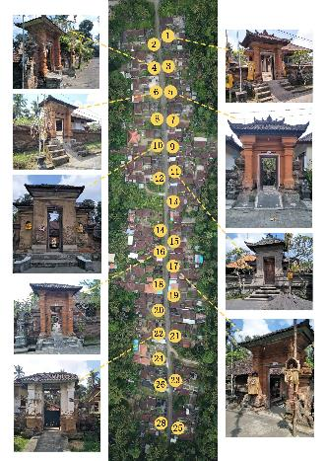

Figure 5. 5 Angkul-angkul data collections
Source : Suryanatha, 2019

From interview and field survey researchers knew that on the main street still preserves “telajakan” or street garden. For details. On each angkul-angkul of housing compounds has telajakan on its right and left side area. Researcher design will be focusing on designing each telajakan for natural visual attraction that can symbolize traditionality through its softscapes and hardscapes arrangements.
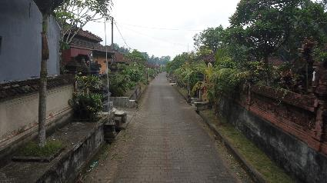

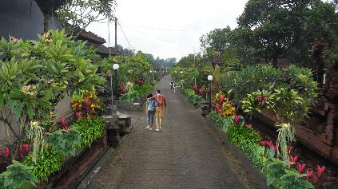

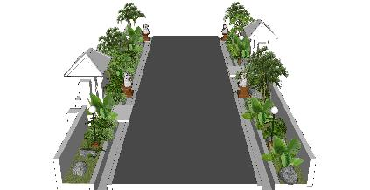

Figure 5. 6 Before-after Planning on Settlement Façade
Source : Suryanatha, 2019

Through measuring, average dimension of telajakan is range from 1 to 2 metres with various length depends on housing compound conditions. With 1 to 2 metres telajakan width, telajakan planning can be done through making vegetation planting area such as flowers, shrubs, or grass. Planting vegetation must be followed by arrangement of hardscapes such as natural stone application, together they can improve visual and traditional ambience of telajakan, as settlement façade. Details on vegetation that will be used for telajakan planning are :

Tabel 5.1 Vegetation Types used in Settlement Facade Planning
Gunawarman, 2019
No. | Vegetasi | Deskripsi | Photo
1 | Jepun Bali  (Plumeria) | Merupakan pohon bunga khas bali yang biasa dipakai dalam upacara keagamaan sebagai sarana menghias dan persembahyangan.
2 | Plawa  (Puring) | Merupakan tanaman perdu khas Bali, daun dari tanaman ini biasa digunakan untuk menghias penjor.
3 | Andong/Hanjuang  (Cordyline Fruticosa) | Sama layaknya plawa, Andong Merupakan tanaman perdu khas Bali, daun dari tanaman ini biasa digunakan untuk menghias penjor. | 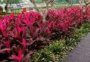
4 | Simbar Menjangan | Merupakan tanaman berdaun layaknya tanduk menjangan, dan biasa hidup menempel pada pohon. Tanaman ini juga banyak dijumpai di rumah-rumah warga bongkasa pertiwi. | 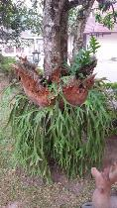
5 | Rumput Lamura | Merupakan jenis penutup tanah (groundcover) yang memiliki karakter kuat pada cuaca panas dan minim perawatan potong.

Designing an Attractive Silver Craftsmans House Compunds

Based on field survey and study, house compound of silver craftsman itself has tourism attraction values. Those attraction value are :
- Housing building masses still preserving original architecture form first it built ( Balinese Traditional Architecture)
- Daily activities ambience from Silver Craftsmans and the family

Those tourism attractions can give uiniques experiences for tourist who visited the house. From that thinking researcher wants to plan a homestay accommodation inside the house compound of Silver Craftsman. Through Homestay planning an alternative tourism can exist by merging tourist need for accommodation and tourism attraction values that can be enjoy. Tourists can get experience on how the Silver Craftsman do daily activities, so with it interaction between them can be construct. Through interaction experience can also give tourist a knowledge on value or meaning in daily routines of tradtional villager way of live, especially regarding uique profession as a traditional silver Craftsman. Silver Craftsman as a unique tourism attraction can also be teaches to tourists who stay at the house, so tourists knew how regarding traditional ways or tools in terms of making silver jewelry in Karang Dalem People ways. So with this planning, design of 3 buildings is needed. First, designing a homestay or homestay room guidelines; second is designing a building function as a gallery to show off silver jewelry products; and third is designing workshop for Silver Craftsmanship Education Attraction for Tourists.
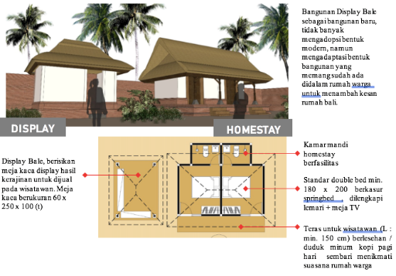

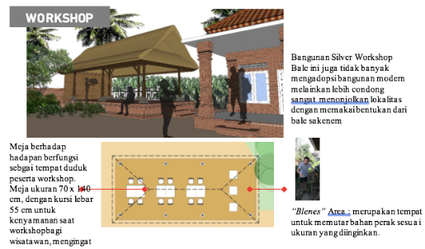
Figure 5. 7 Display Gallery, Homestay, and Workshop Planning
Source : Suryanatha, 2019

Homestay buildings that built in the house compound area has its own standard. This standard’s purposes is for keeping comfortable feeling for tourists when they stay at the homestay. One of the standard that the most important is using local traditional architecture building style. Those standard means to keep ambience inside villagers house strong on traditionality feelings. So its unique selling point as tourism attraction can be sustain.

- CONCLUSION
Researcher hope that all Design that proposed for revitalization on Traditional Silver Craftsmanship in Karang Dalem I Settlement can be done and bring many tourist to come after the construction finished. Tourism attraction not only achieved by natural elements or natural wonders buat also can be made and enjoyable in the form of interaction, experiencing, and education. Through Settlement Façade improvement by arranging vegetation and hardscapes with the theme traditionality – can give first welcome to tourist indirectly before they continue on entering silver craftsman house or other villager house. Through Designing Homestay, Display Gallery, and Workshop many attraction can be given to tourist by the host and with its unique silver-jewelry making education combined tourism hospitality can be achieved through in the form of education, interaction, social values, traditional values, etc.

REFERENCES
A’inun N., Fildzah; Krisnani, Hetty; Darwis, Rudi Saprudin. 2018. Pengembangan Desa Wisata Melalui Konsep Community Based Tourism. Prosiding KS: Riset & PKM Vol. 2 No. 3 Hal 301- 444 ISSN : 2442-4480
Badan Pusat Statistik
Bali.tribunnews. (2015, 16 Agustus). Pengrajin Perak Tradisional Terancam Punah. Mereka Dikalahkan Mesin. Diperoleh 20 Oktober 2018, dari http://bali.tribunnews.com/2015/08/16/pengrajin-perak-tradisional-terancam-punah-mereka- dikalahkan-mesin
Meliala, Andi Suranta ; Matondang, Nazarudin dan Sari, Rahmi M. 2014. Strategi Peningkatan Daya Saing Usaha Kecil dan Menengah (UKM) berbasis Kaizen. Jurnal Optimasi Sistem Industri, Vol.3 No.2 April 2014 : 641-664. ISSN 2088-4842
Setyanto, Alief Rakhman ; Samodra, Bhimo Rizky dan Pratama, Yogi Pasca. 2015. Kajian Strategi Pemberdayaan UMKM dalam menghadapi Perdagangan Bebas Kawasan ASEAN. Etikonomi Vol 14 (2) Oktober 2015 P-ISSN : 1412-8969 ; E-ISSN : 2461-0771
Sonalia, Devi dan Hubeis, Musa. 2013. Pengendalian Mutu Pada Proses Produksi di Tiga Usaha Kecil Menengah Tahu Kabupaten Bogor. Jurnal Manajemen dan Organisasi Vol IV No.2, Agustus 2013
Utaminingsih, Adijati. 2016. Pengaruh Orientasi Pasar, Inovasi dan Kreativitas Strategi Pemasaran terhadap Kinerja Pemasaran pada UKM Kerajinan Rotan di Desa Teluk Wetan, Welahan, Jepara. Media Ekonomi dan Manajemen Vol.31 No.2 Juli 2016 P-ISSN : 0854-1442 E- ISSN : 2503-4460
Zakaria, Faris;Suprihardjo, Rima Dewi. 2014. Konsep Pengembangan Kawasan Desa Wisata di Desa Bandungan Kecamatan Pakong Kabupaten Pamekasan. Jurnal Teknik POMITS Vol. 3 No.2 (2014) P-ISSN : 2301-9271 E-ISSN : 2337-3520.

